

PARLIAMENTARY PROCEDURE TEAM
(550)

~PRELIMINARY~
NATIONAL 2021
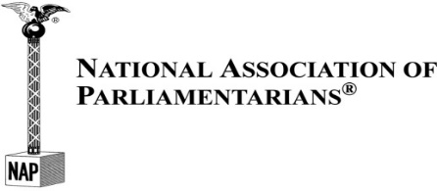

TOTAL POINTS __________
(Refer to Judge’s Scoring Rubric/Rating Sheets)

PARLIAMENTARY PROCEDURE DEMONSTRATION

The team will be allowed a preparation period of 15 minutes before giving a parliamentary demonstration to the judges. The team will be limited to a maximum of 15 minutes for parliamentary demonstration to the judges.

A blank 3" x 5" index card will be provided to each team member, which may be used during the presentation. In addition, the secretary will receive one blank sheet of paper to record the proceedings of the meeting in English, long hand for submission to the judges immediately after the presentation. The secretary will be permitted to take the contest agenda into the presentation room; this is to be submitted with the minutes to the judges.

The parliamentary authority, Robert’s Rules of Order Newly Revised (11th Edition), or any other reference materials, may be used in the preparation room but not during the parliamentary demonstration.

The items listed below are the order of new business for each subject listed. Items under “Abilities to be Demonstrated” may be rearranged within subject areas.

Subject | Abilities to be Demonstrated
- Parliamentary Procedure team to host training | - Main Motion
for student organizations | - Withdraw a Motion
 | - Parliamentary Inquiry
 | - Recess
- Setup BPA Week display at local library | - Main Motion
- Commit or Refer
- Amend
 | - Amend the Amendment
- Parliamentary Procedure demonstration to | - Main Motion
local school board | - Request for Information
 | - Limit Debate
 | - Lay on the Table

